Recurring ACH Payment Authorization

You authorize regularly scheduled charges to your checking/savings account. You will be charged the amount indicated below each billing period. A receipt for each payment will be provided to you and the charge will appear on your bank statement as an “ACH Debit”. You agree that no prior-notification will be provided unless the date or amount changes, in which case you will receive notice from us at least 10 days prior to the payment being collected.

I _______________________ authorize City Church Ministries to charge my
(Full Name)

bank account indicated below for $________________ on the 15th of Each Month.
(Amount $)

This payment is for support of the Centre County Orphan Care Alliance.

Billing Information

Billing Address __________________________________Phone # ___________________________

City, State, Zip __________________________________ Email _____________________________

Bank Details

☐ Checking ☐ Savings

Account Name _________________________
Bank Name _________________________
Account Number _________________________
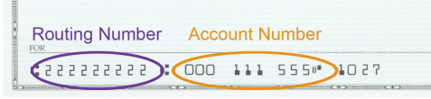
Routing Number _________________________

I understand that this authorization will remain in effect until I cancel it in writing, and I agree to notify --__City Church Ministries__ in writing of any changes in my account information or termination of this authorization at least 15 days prior to the next billing date. If the above noted payment dates fall on a weekend or holiday, I understand that the payments may be executed on the next business day. For ACH debits to my checking/savings account, I understand that because these are electronic transactions, these funds may be withdrawn from my account as soon as the above noted periodic transaction dates. I acknowledge that the origination of ACH transactions to my account must comply with the provisions of U.S. law. I certify that I am an authorized user of this bank account and will not dispute these scheduled transactions with my bank; so long as the transactions correspond to the terms indicated in this authorization form.

SIGNATURE ___________________________ DATE _____________________
(Account Holder’s Signature)

